How to import validation metadata into your MS Access template for a specific dataset.

- Download validation metadata from DD

In DD go to the view of the dataset for which you need the validation metadata. Press the MS Access icon next to "Create validation metadata for MS Access template" (you must be logged in to see it!). This will download an MS Access file containing the metadata for automatic validation. You must save that file somewhere on your computer. The file contains only one table titled "VALIDATION_METADATA_DO_NOT_MODIFY". Your task is to import that table into your MS Access template. You can do this as described in the next point.

- Importing validation metadata into your MS Access template

Open your MS Access template. From the menu, choose Insert -> Table. You will see a window like the one below.

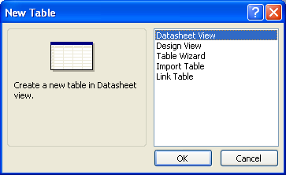

Select 'Import table' and press OK. As a result, you will see a window where you must locate the file you downloaded in point 1. Once you've done that and pressed 'Import', you will see a window like this:

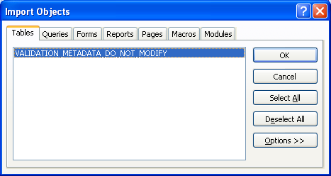

The window displays tables you can import. There is only one table, the one mentioned in point 1. Select it and press OK. As a result, that table is imported into your MS Access template and you are done! You will see the table listed in your MS Access template:

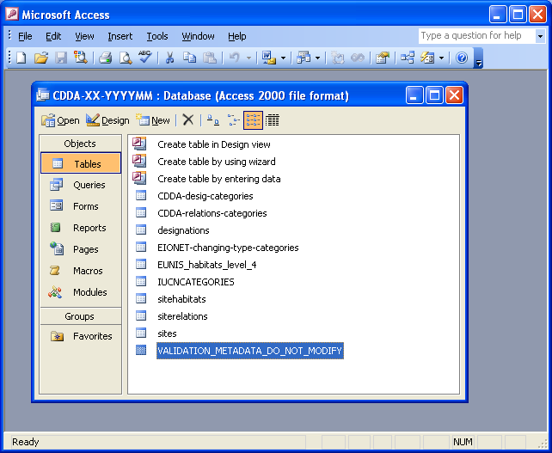

As an extra, you can make that table hidden. For this, right-click it and choose 'Properties'. In the opening window (below), check 'Hidden' and press OK. This way end users will not see that table.

